Civ Pro Notes 10/25

Supplemental Jurisdiction
Art III §2 Focuses on Cases and Controversies as a Whole
that is why it is constitutional for an action that does not have its own source of SMJ to be in federal court with one that does

but there remains the question of whether SMJ for the actions is statutorily allowed

Supplemental Jurisdiction Statute 28 U.S.C. § 1367 passed to override SCt decision in Finley, codified supplemental jurisdiction requirements
1st Step: Constitutional Analysis- is the action part of the same constitutional case or controversy as the action with original SMJ?
e.g. does it share have a common core of operative fact?
2nd Step (Only if Federal Action is based solely on Diversity): Statutory Analysis using §1367(b)
(b) In any civil action of which the district courts have original jurisdiction founded solely on section 1332 of this title, the district courts shall not have supplemental jurisdiction under subsection (a) over claims by plaintiffs against persons made parties under Rule 14, 19, 20, or 24 of the Federal Rules of Civil Procedure, or over claims by persons proposed to be joined as plaintiffs under Rule 19 of such rules, or seeking to intervene as plaintiffs under Rule 24 of such rules, when exercising supplemental jurisdiction over such claims would be inconsistent with the jurisdictional requirements of section 1332.

notice these exceptions are a problem only for actions brought by a plaintiff

so –
- Hypo #10
  - P (NY) sues D (NY) under federal securities law in federal court
P joins under R 18(a) a state law fraud claim against D
D impleads insurer I (NY) for state law contract claim
D also brings compulsory counterclaim for breach of contract (P didn’t pay all the money he owes under the securities contract)

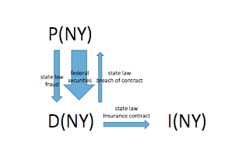
all of these actions have supplemental jurisdiction – they are all part of the same constitutional case or controversy and because the core action is federal question that is all that matters

what if the D is granted summary judgment on the federal securities action?
must the court dismiss the state common law fraud action?
it does not have to – they still have supplemental jur
what if the D gets the federal securities action dismissed for failure to state a claim?

they still have suppl jur

it can at its discretion dismiss the actions however
(c) The district courts may decline to exercise supplemental jurisdiction over a claim under subsection (a) if -
(1) the claim raises a novel or complex issue of State law,
(2) the claim substantially predominates over the claim or claims over which the district court has original jurisdiction,
(3) the district court has dismissed all claims over which it has original jurisdiction, or
(4) in exceptional circumstances, there are other compelling reasons for declining jurisdiction.

- P(NY) and D(NY) wish to litigate their state law battery action in federal court before their friend, federal judge X, who is willing
- how to overcome the problem of SMJ?
- P sues D in federal court claiming that D’s hitting him was a violation of federal securities law
- P joins to the federal action a state law battery action
- when the federal securities law action is dismissed for failure to state a claim, there is still SMJ for the battery action
- should this work...?

NO – in this case the federal action is not colorable so it will be dismissed for lack of SMJ not failure to state a claim – as a result there cannot be suppl jur for the other actions

§1367(d) allows for claims dismissed under §1367(c) to be brought in State Courts, dictates a new tolling of the statute of limitations (possibly cuts into State’s authority over their courts)

§1367(d) The period of limitations for any claim asserted under subsection (a), and for any other claim in the same action that is voluntarily dismissed at the same time as or after the dismissal of the claim under subsection (a), shall be tolled while the claim is pending and for a period of 30 days after it is dismissed unless State law provides for a longer tolling period.
- Jinks Case about the constitutionality of §1367(d), Court held that the statute helps encourage people to take claims to federal court without the fear of their state law claims being barred from state court on statute of limitations grounds if they are dismissed under 1367(c)
- it is constitutional even though Congress is regulating the procedure of state courts because the regulation is only to protect the jurisdiction of federal courts

Hypo #1- A (NY) sues B(NY) under fed securities laws
A joins state common law fraud claim against C (NY), an auditor for B who was also responsible for the fraud
- Permissible Joinder under Rule 20(a)
- Supplemental Jurisdiction exists because action A -> C concerns the same nucleus of operative facts as claim A->B which has original jurisdiction
- Since A->B is federal question, that is the only question
- This is incidentally similar to the pendant party jurisdiction which the SCt rejected in Finley and Aldinger – it was those two cases that motivated Congress to pass 1367

#1(b) Assume A also joins a state law action for a battery occurring a few weeks before the fraud against C
- Allowed under 14(a) but no supplemental jurisdiction, not the same nucleus of operate facts

Hypo #2- A (Cal.) sues E (Nev.) (B’s employer) under state law for a battery committed by B (Cal.)
- E impleads B
Acceptable under Rule 14 (E claiming B is liable to E for all or part of E’s liability to A)
- There is suppl jur for this impleader
- B then brings joins an action against A on the harm done to B in their fight
- This is allowed under R 14
- 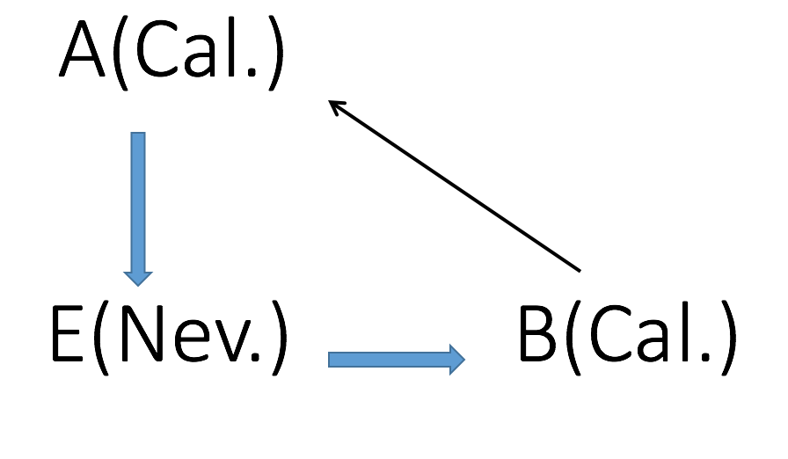
Supplemental Jurisdiction exists, even though B and A are not diverse
- same const’l case or controversy as A v. E and even though one might have to woryy about the exceptions to suppl jur in 1367(b), because A v. E is solely a diversity case, B v. A is not brought by a plaintiff so the exceptions don’t apply

- What if you switch and it is A bringing an action against B?
- 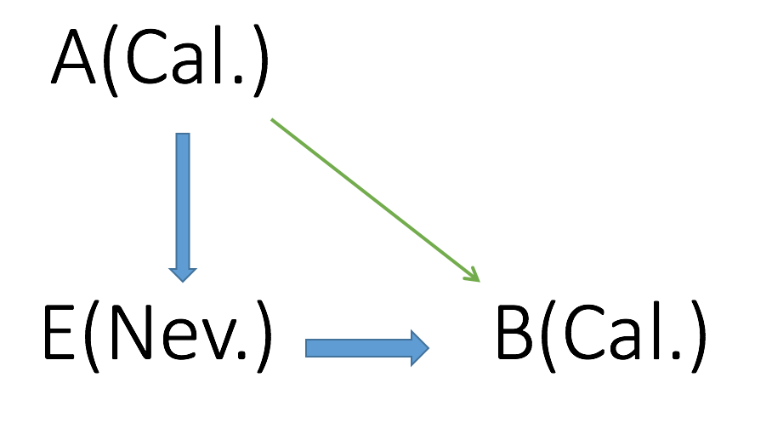
Acceptable joinder claim under Rule 14, but no supplemental jurisdiction because it falls under the exception of §1367(b) – it is a claim by a plaintiff against someone made a party under R 14, where exercising suppl jur would be inconsistent with the jurisdictional requirements of section 1332.

Hypo #3 - P (Cal) sues D (Cal) under federal securities laws. D joins an action against P for battery, asking for $100k
No supplemental jurisdiction, claim DP is not within the same core of operate facts as the original action – not part of the same const’l case or controversy

Hypo #4- P (Cal) sues D (Ore) for state law breach of contract, asking for $100K. D joins an action against P for battery, asking for $25k.
- No supplemental jurisdiction, D P is a permissive counterclaim (Rule 13(b)), so claim DP is not part of the same const’l case or controversy

- Majority of Courts say cannot aggregate counterclaim amounts with the original amount to reach amount in controversy
Hypo #5 - P (NY) sues D (NJ) for battery asking for $100K. D impleads X (NY) a joint tortfeasor for contribution
X brings 14(a) claims against P from damages from same accident
P brings compulsory counterclaim against X for damages from the accident
- is there suppl jur?
- there should be: P is not using suppl jur to try to get around the requirements for complete diversity – is only bringing P v. X because D impleaded X and X joined an action against P
- BUT argument that there is not –
  - Although part of same const’l case or controversy as P v. D, it falls under the exception to suppl jur in 1367(b)
    - Claim by P against someone made a party under R 14
  - Some courts try to get around this by saying that P v. X is a claim by a counterclaim plaintiff not a simple plaintiff

Hypo #6- P (NY) sues D1 (NJ) for state law battery asking $100k and D2 (NJ) asking $25K.
No supplemental jurisdiction, Exception applies because D2 made party under Rule 20, Claim PD2 destroys diversity

Hypo #7- P1 (NY) sues D (NJ) under state law battery for $100k and joins with P2 (NY) who sues D for $25K.
Supplemental Jurisdiction exists – P2 v. D does not fall under this language
Claims by plaintiffs against persons made parties under Rule 14, 19, 20, or 24 of the Federal Rules of Civil Procedure, or over claims by persons proposed to be joined as plaintiffs under Rule 19 of such rules, or seeking to intervene as plaintiffs under Rule 24 of such rules,

- P2 v D is a claim by a person proposed to be joined as a plaintiff under R 20

This is what was held by the SCt in Allapattah

Hypo #8 - P1 (NY) sues D (NJ) under state law battery for $100k. D makes a motion to join P2 (NY), who has a claim against D for $25K, as a necessary party
- No Supplemental Jurisdiction, it is a claim made by a person proposed to joined as a plaintiff under Rule 19

Hypo #9 - P1(NY) sues D (NJ) for $100k and joins with P2 (NJ) who sues D for $100K
- No suppl jur – according to Allapattah
- To have Supplemental Jurisdiction, Court needs to have original jurisdiction over a claim and joining P2 infects the diversity of P1’s claims, so P1 v. D does not have original jurisdiction
  - Amount in Controversy not being reached by one claim does NOT ‘infect’ an original claim’s amount in controversy threshold

Hypo #10 - P(Cal) sues D(Cal) in state court in Cal under 42 U.S.C. § 1983 for violations of his civil right. Joined to the action is an unrelated state law breach of contract action against D.
May D successfully remove?
- No supplemental jurisdiction, state law contract action is not related to the original claim
- Triggers 28 U.S.C. §1441(c), allows case to be removed to Federal Court and the Fed Court can sever the two claims, remanding the state law claim back to state court

- U.S.C. §1441(c) Joinder of Federal law claims and State law claims.--(1) If a civil action includes—
(A) a claim arising under the Constitution, laws, or treaties of the United States (within the meaning of section 1331 of this title), and
(B) a claim not within the original or supplemental jurisdiction of the district court or a claim that has been made nonremovable by statute, the entire action may be removed if the action would be removable without the inclusion of the claim described in subparagraph (B).
(2) Upon removal of an action described in paragraph (1), the district court shall sever from the action all claims described in paragraph (1)(B) and shall remand the severed claims to the State court from which the action was removed. Only defendants against whom a claim described in paragraph (1)(A) has been asserted are required to join in or consent to the removal under paragraph (1).

Discovery
Scope of Discovery: Unless otherwise limited by court order, Parties may obtain discovery regarding any nonprivileged matter that is relevant to any party's claim or defense and proportional to the needs of the case,
Proportionality considerations: (1) the importance of the issues at stake in the action, (2) the amount in controversy, (3) the parties’ relative access to relevant information, (4) the parties’ resources, (5) the importance of the discovery in resolving the issues, and (6) whether the burden or expense of the proposed discovery outweighs its likely benefit.
- Information within this scope of discovery need not be admissible in evidence to be discoverable.

Privileges which bar discovery
- Privilege against self-incrimination – Doesn’t apply in a civil action, cant invoke privilege if statement would make you liable for damages, but DOES apply if statement would subject them to criminal liability
- Attorney-Client Privilege – Restatement §68:
- Protects the communications between a client and their attorney (also includes those people necessary to that relationship)
  - May be invoked with respect to (1) a communication (2) made between privileged persons (3) in confidence (4) for the purpose of obtaining or providing legal assistance for the client
  - Why does this privilege exist?
    - To make sure client and lawyer’s discussions are honest and open, not worried about the other side/court hearing your conversations
- Eg your client tells you that he was looking the other way when he drove into the plaintiff
your client receives an interrogatory asking whether he said to you that he was looking the other way when he drove into the plaintiff
does your client have to answer the interrogatory? NO A-C priv applies
- BUT if the interrogatory asks whether your client was looking the other way when he drove into the plaintiff does he have to answer?
- YES – your client cannot refuse to answer a question relevant to the case simply because the answer was communicated in an A-C privileged communication
  - This is sometime put as this way: the A-C privilege does not protect facts, only communications
  - Notice things are different in a criminal case because your client xan simply refuse to testify
- what if your client says he was not looking the other way on the stand?
  - You have to notify the ct that your client is lying
- So what good is the AC priv? Clients will not be encouraged to speak freely even with the AC priv because they know that if they say something bad their lawyer will force them to be truthful about it in discovery or on the stand
- Well, the AC priv does do something…
- - your client tells you that he was looking the other way when he drove into the plaintiff
- subsequently he credibly tells you that he was not actually looking the other way at the time of the accident – when he said that he was he was feeling guilty because he looked the other way about 20 seconds before the accident
- your client receives an interrogatory asking whether he said to you that he was looking the other way when he drove into the plaintiff
- does your client have to answer the interrogatory? NO AC priv

- your client receives an interrogatory asking whether he was looking the other way when he drove into the plaintiff – what can your client say? He wasn’t

- so the AC priv does keep prejudicial communications from getting to the other side

