Civil Procedure | Green | Fall 2017
Notes: 8/21/17

Review Sessions: TBD
Class Website: msgre2.people.wm.edu/civpro.htm
Midterm: outside of class and not recorded graded, but will be graded and feedback given

Outline of Class Notes for Today:
- What is Civil Procedure?
- Why it is a hard class?
- Three main themes in course
- State and federal jurisdiction

What is Civil Procedure?
- Procedure v. Substance
  - Procedure: Court Law; process case will go through
    - Constitutes the court and regulates its activity
  - Substance: the law that regulates peoples activities outside of court

Civil v. Criminal
- Civil: anything not criminal, is civil; is the way the bulk of law is enforced
- Criminal: could end up to losing the liberty of individuals

Most cases do not go to trial | Only 1-2% go to trial | Settled or disposed before trial
- that is why we will concentrate on pre-trial procedure
- also on procedure of federal courts

Why is civil procedure so hard?
- Not familiar with activity being legally regulated
- Interdependencies: talking about one rule, but mention a rule that the other is dependent upon – all connected and work as a large web
- Regulatory/Statutory very different than common law
- Dynamic – laws keep changing ever year
- Structure of legal system is central to understanding this course
  - Federal v. State Relations – The relations between each and how they work
- Separation of powers (Congress v. Federal Courts)
- State vs. State (California v. New York)
- Even international (France v. New York)
- always need to know what law you are learning – e.g. concerning the relevant federal law governing a federal court, might be…
  - Constitutional law
  - statutory law
  - Fed. R. Civ. P.
  - Common Law

Why is civil procedure so important?
It is the way substantive law is enforced. If there weren’t procedure, there wouldn’t be a method to require you to do what you are legally obligated to do. Substantive law is only as powerful as procedural law.

Three Themes
- Balance: What is this law trying to do? balance three concerns
  - Accuracy: determining what actually happened, choosing the proper law, and accurately applying
  - Autonomy (other interests, e.g. privacy): it seems to appear important to have individuals autonomous and not the government in charge of how litiogation proceeds
    - Negative consequences: accuracy/efficiency
  - Efficiency: sometimes accuracy is sacrificed in name of efficiency; some wrong outcomes do appear because it is expensive to avoid them
- Structure of American Legal System
  - Relationship between the different level of government and other nations
- Statutory Interpretation
  - How/ways to interrupt a statute or regulation

Structure of Court Systems – division between trial courts and appellate courts
trial courts find facts (usual through jury) and issue judgment
- appeal determines whether there were legal errors

- Federal Court System
  - trial courts - U.S. District Court
    - E.g. E.D. Pa.
    - will be out focus
  - U.S. Court of Appeals (intermediate appellate court)
    - E.g. 3rd Circuit
    - right to appeal
  - U.S. Supreme Court
    - discretionary appeal

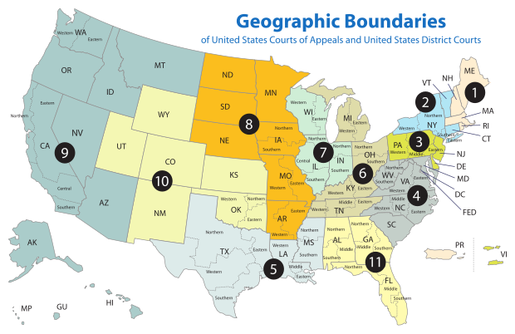

- Virginia Court System
  - Trial court: Circuit Court (also General District Court)
  - Court of Appeal
    - Most states have intermediate courts, which hears most appeals
  - Virginia Supreme Court

Example Case:
- Joe sues Jane in VA circuit court (a state trial court) under VA negligence law in connection with a car accident in VA; he loses; he appeals up the VA state court system to the VA Supreme Court, but still loses
- Is this the end of things?
  - Not necessarily. Can go to the US Supreme Court if there is a federal issue such as “unconstitutionality” of VA state law

Example Case:
- Joe sues Jane in E.D. VA. Under VA negligence law in connection with a car accident in VA; he loses; he appeals to the 4th Circuit but still loses
- Is this the end of things?
  - If only questions of VA law then can’t up to US Supreme Court
  - If there is a question of federal law then appeal is possible (if US SCt chooses to take case)
  - US SCt is not an authority on VA state law
  - Cannot appeal to VA Supreme Court from federal court on issue of VA law either, even though it is the final authority on VA law
    - there is no appeal from the federal court system to a state court system
  - the federal court has no authority of state law – it will simply opine about what it thinks VA law is without issuing judgments that are binding on VA state courts

3 Requirements to Consider in Counsel Choosing the Proper Court
- Subject Matter Jurisdiction
- Personal Jurisdiction
- Venue

Subject Matter Jurisdiction (SMJ): the authority of a court system to hear cases of a particular type
- State courts are general subject matter jurisdiction – the state court system can hear any type of case (with one exception to be discussed)
- but there are specialized courts in states
  - Such as domestic relations courts, family court, probate court, estate court, etc.
  - SMJ will arise in state court concerning these matters
  - if there is no SMJ in that court that just means there is SMJ in another type of court in that state

Example Case:
- Joe (Cali) and Fred (Cali) get into a fight in a bar in San Francisco. Joe sues Fred VA state court. Is there SMJ?
- Yes. Under SMJ, they can take it. ABSOULTELY. States can hear any type of case: i.e. other state’s law, federal law
  - However, there may be other problems besides SMJ - personal jurisdiction can limit the power of a court to issue a binding judgment on an unwilling defendant

Personal Jurisdiction: this is about the power of a court over an unwilling defendant from outside the jurisdiction
- There is no problem with personal jurisdiction if both parties – really D – consents to the trial out of state or waives it

Venue: where within a c. system can a case be brought
- Question of Venue: “Should we hear the case in town x or town y?” (State)
- Question of Venue: “Should we hear the case in District x or District y?” (Federal)

Subject Matter Jurisdiction is a problem within the federal court system and not really within the state courts. Federal court have the problem of possibly stepping on the toes of state courts.

Example Case:
Gunter (German) and Helmut (German) get into a fight in a bar in Berlin. Gunter sues Helmut in VA state court. Is there SMJ?
- YES because VA State Court has general subject matter jurisdiction
- Possible limitation is personal jurisdiction

Example Case:
Joe (Cali is arrested by Fred (Cali) in San Fran. Joe sues Fred in VA state court for violations of his federal constitutional rights. Is there SMJ?
- YES because VA state court has general subject matter jurisdiction – they can hear any type of case, even a case under federal law

- Concurrent Jurisdiction: there is usually concurrent jurisdiction for actions under federal law - what could be brought in federal court may also be brought in state court
  - EXCEPTION to Concurrent Jurisdiction: Congress may provide that some cases may only be heard in federal c.
    - Exclusive Federal Jurisdiction
      - i.e. admiralty, patent/copyright, bankruptcy

THE RULE:
Concurrent federal subject matter jurisdiction for federal actions
Be heard in state or federal courts

THE EXCEPTION:
Exclusive federal subject matter jurisdiction
Patent/copyright, bankruptcy, etc.

