Tagging - Burnham
- NJ couple separates
- wife and 2 children move to Cal.
- husband visits for 3 days on business and to visit children
- she has him served for divorce and monetary relief in California state court

Sct upholds in-hand service in the forum state as a source of personal jurisdiction
- but cannot agree on the reason

Scalia (Rehnquist & Kennedy)
- If OK at time of enactment of 14th A (and generally accepted by states today) it’s OK now even if it does not satisfy Int’l Shoe standard
- Int’l Shoe standard adds sources of personal jurisdiction but cannot override sources of personal jurisdiction that were available at the time of the enactment of the 14th amendment and that are still generally use by the states today

Is Scalia’s approach compatible with Shaffer?
  - Arguably – although the method of quasi in rem jurisdiction used in Shaffer was probably OK at the time of pennoyer, it was not generally used by the states
    - Delaware’s attempt to assert quasi in rem on the basis of shares in Delaware corporations was unusual
  - On the other hand, quasi in rem jurisdiction on the basis of real property would probably be OK for Scalia, since it was OK at the time of the enactment of the 14th amendment and is still generally used by the states today
- Green: Scalia’s theory accounts for the current case law, but it seems ad hoc

what’s Brennan’s reasoning (Marshall, Blackmun & O’Connor)
- argues that all forms of personal jurisdiction must satisfy the requirements of Int’l Shoe,
- but thinks that tagging generally satisfies Shoe
- D has the protection of state while there etc.
- Green: hard to see how these benefits are sufficiently great to justify the defendant being subject to personal jurisdiction for any cause of action
- Brennan’s theory that all forms of personal jurisdiction must satisfy Shoe is more conceptually satisfying, but it would appear to follow that tagging on its own is unconstitutional as a source of personal jurisdiction

- A different theory that might explain why tagging is constitutional is that the defendant can reasonably anticipate being subject to personal jurisdiction
  - the quid pro quo may not be a fair one (and thus Shoe may not be satisfied) but at least the defendant knows what he’s in for by going to a state

- note that in Burnham there may have been specific personal jurisdiction, independently of tagging

- The defendant’s children were in California and they were getting the protection of the state’s laws
- Furthermore, the cause of action related to those benefits – the action was for divorce and child support
- D did not ask that they go to CA though…

Five general considerations that arise in personal jurisdiction cases
- Pennoyer theory
- International Shoe power theory
- McGee factors
- Can the defendant reasonably anticipate PJ due to actions?
- Scalia’s theory – OK if OK under Int’l Shoe but also OK if OK under Pennoyer and still used by states today

Outline of PJ
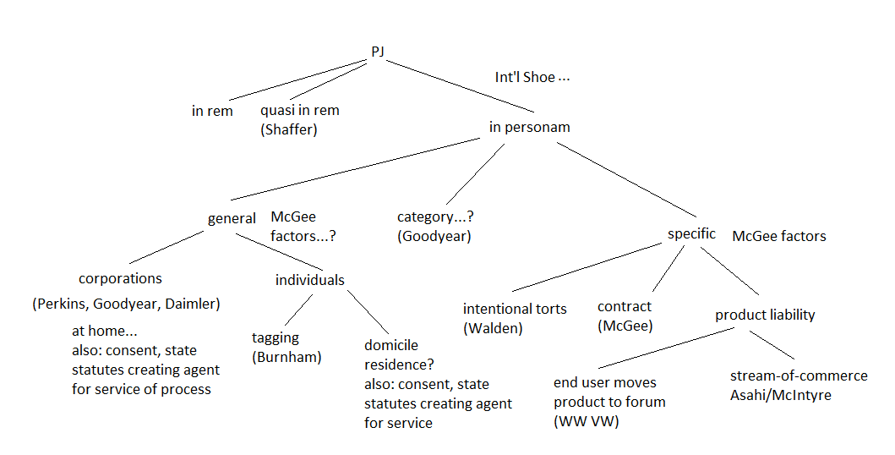
Run through some examples from old exams

P (a citizen of Nebraska) sues D (a citizen of New York) for $100,000 damages in Nebraska state court in connection with a brawl that occurred in Illinois. D has never been to the state of Nebraska and owns no property there. D appears to argue that the Nebraska state court lacks personal jurisdiction over her. Under Nebraska state law, however, motions to dismiss for lack of personal jurisdiction are not allowed: Anyone appearing before a Nebraska state court, even when arguing lack of personal jurisdiction, submits himself to general personal jurisdiction.
D argues that the Nebraska state law is unconstitutional. Is she right?
- no special appearances allowed

how to answer
- not enough to say OK under Pennoyer (York v. Texas)
- What about Now? (think of Shaffer, which struck down a form of PJ that was OK under Pennoyer)
- what cases to look at? Burnham/Shaffer
  - These are cases that consider forms of personal jurisdiction that were OK under Pennoyer but that are difficult to justify under Shoe

- could say that this is in effect a form of tagging and tagging good under Burnham so OK now
- BUT Burnham involved case where D came willingly and for business
- here D is appearing only to argue no PJ
- Brennan theory in Burnham
  - must satisfy Int’l Shoe
    - Arguably does not, because the defendant is not willingly getting the benefits of protection of the forum state

- Scalia theory in Burnham
  - Arguably does not satisfy his theory either
  - – it is true that the denial of a special appearance was permissible at the time of the enactment of the 14th amendment
  - But it is not generally accepted today by the states
  - states allow special appearances

Q. The D Corp (incorporated in Oregon) manufactures thimbles. It engaged in a national search to locate a suitable engineer to work at its only manufacturing plant, located in Medford, Oregon. The search involved a number of advertisements in a trade publication with a national circulation and the use of a company that specializes in recruiting highly trained employees. In the end, the recruitment company located P, who lived in Yreka, California – only 50 miles from Medford, Oregon. In a letter sent from the D Corp’s main office in Medford to P’s home in Yreka, the D Corp offered P a job, which P accepted. P decided to continue living in Yreka and to commute the fifty miles to work. That P continued to live in California was known to the D Corp.
P got into a serious accident working on a machine at the Oregon factory and decided to sue the D Corp under state-law negligence concerning the design of the machine. P brought his suit in the Federal District Court for the Eastern District of California (which includes the town of Yreka). The D Corp made a motion to dismiss for lack of personal jurisdiction.
The D Corp’s other contacts with the state of California are the following: The D Corp’s thimbles are sold all over the world, including in California, although distribution of the thimbles is through an independent distributing company that takes ownership of them at the D Corp plant in Oregon. The D Corp sells about 100,000 thimbles per year in California (around 33,000 of which are sold in the Eastern District of California). The California sales of its thimbles amount to around $10,000 per year and constitute around 3% of the D Corp’s total yearly production. The D Corp does not advertise its thimbles in California, nor does it own property, maintain an office, or have an agent for service of process there. Should the D Corp’s motion succeed?

-PJ only if a state court in CA would (according to Fed R Civ P 4(k)(1)(A)
- CA long-arm statute is up to the limits of due process

- superficial resemblance to Asahi, McIntyre stream of commerce cases
- but these stream of commerce cases are specific jurisdiction cases
  - defendant’s product in the forum state gave rise to the cause of action.
- Here P’s cause of action concerns harm he suffered from a defective machine at the thimble factory in Oregon
- shipments of thimbles to CA are relevant insofar as they could give rise to general PJ – that is PJ over the D Corp for any cause of action, even those unrelated to the CA thimble contacts.
- but that is unlikely given Goodyear
  - and Daimler
  - even category jurisdiction would not work, because the cause of action does not concern thimbles of the sort that make it a California
      - It concerns a defective machine

  - specific jurisdiction?
    - How did D Corp’s reach out to California when looking for someone to fill the engineer position?
      - by advertising for position in CA (although P did not, it seems, ever read the ads) and, more importantly, by hiring a recruiting company that ultimately contacted P in CA. Another contact is the D Corp’s sending the offer letter to CA.
- some connection with the cause of action, because they are related to P and his employment at the D Corp.
    - But not a case like McGee, where the letter sent to the state was the very contract being sued upon. P is not suing concerning his employment contract – he is suing under tort concerning the machine at the thimble plant in Oregon.
    - one might say but for the hiring of the recruiting firm and the sending of the offer letter, P would not have taken the job and so would not have gotten into the accident in Oregon.
      - but this is a difficult argument

PJ in Fed ct

Constitutional restriction
Due process clause of the 5th Amendment
Does the United States have power over the defendant for this cause of action?
Look to contacts between the defendant and the United States

Further limit in Fed. R. Civ. P. 4(k)

Fed R. Civ. P. 4(k)(1)(A)
does lion’s share of work
- service is sufficient for PJ over person in federal ct
- (A) who could be subjected to the jurisdiction of a court of general jurisdiction in the state in which the district court is located…

Exists to keep Ps from using broad constitutional PJ power of federal courts to bring suit in an inconvenient forum – e.g.

- P (NY) sues D (NJ) for a state law battery that occurred in New York City.
- P brings the suit in federal court in Alaska
- D is served in NJ
- D has never visited Alaska and has never had any contact with the state
- without 4(k)(1)(A) there would be PJ

4(k)(1)(C)
PJ also when authorized by a federal statute
- Some federal statutes have their own provision granting more generous PJ than 4(k)(1)(A)

Finally 4(k)(2)

(2) Federal Claim Outside State-Court Jurisdiction. For a claim that arises under federal law, serving a summons or filing a
waiver of service establishes personal jurisdiction over a defendant if:
(A) the defendant is not subject to jurisdiction in any state’s courts of general jurisdiction; and
(B) exercising jurisdiction is consistent with the United States Constitution and laws.
P (Va.) brings suit in federal court in Virginia against D, a German domiciliary residing in Germany, for a battery that the German committed against him in New York. The German has no other contacts with the United States besides the brief trip to NY during which the alleged battery occurred.
Is there PJ? NO. 4(k)(1)(A) does not allow it and 4(k)(2) does not apply because the suit is not under federal law and the D is subject to PJ in NY.
terrorist is sued under a federal antiterrorism act allowing for American victims of foreign terrorism to sue for damages. (The alleged acts of terrorism in this case occurred in Turkey.) The action is brought in federal court in New York.

Is there PJ? This is arguably a case for 4(k)(2), assuming that D has sufficient contacts with the US to satisfy 5th Amendment due process.

- In which of the following cases is there PJ – all are brought in SDNY

- a. A federal civil rights action concerning the defendant’s arrest of the plaintiff in Buffalo (in the Northern District of New York). Defendant lives in Pennsylvania and is served there.
- There is specific PJ. The defendant’s actions in New York gave rise to the cause of action.

- b. A California state-law product liability action brought as a diversity action by a California plaintiff against a corporation incorporated in Delaware with its principal place of business in Tennessee. The defendant corporation has a large factory in Buffalo, New York (in the Northern District of New York), but the plaintiff at no time has this asset of the corporation attached by the federal court. The defendant corporation is served (through service on its Chief Legal Officer) in Tennessee.

- Probably no PJ. Unlikely that there would be general personal jurisdiction over the defendant in NY under Goodyear and Daimler.

- NOTE: would be different if the product at issue was made in the Buffalo factory. Then it would be a simple case of specific PJ – D reaches out to NY in connection with the cause of action

- c. A California state-law diversity action concerning a brawl between the plaintiff and the defendant in California. The plaintiff is a citizen of California and the defendant a citizen of New York. The defendant is served while on a business trip in California.

- There is PJ in NY. The defendant is a citizen of New York and so is domiciled there. Domicile is a clear source of general personal jurisdiction.

- d. An action by a New York citizen against a California citizen for violation of a federal antiterrorism act. The defendant’s alleged violations of the federal act were all committed in Iraq. The defendant has no contacts with the state of New York. The action is brought in the Federal District Court for the Southern District of New York.

- There would be no PJ in a state court in New York. There are no Int’l Shoe connections with the state of New York. Those who thought there was PJ might be thinking of FRCP 4(k)(2), which would allow for PJ even if a New York state court would not have PJ. But that provision would allow for PJ only if the defendant “is not subject to the jurisdiction of the courts of general jurisdiction of any state.” This defendant is a California citizen and so would clearly be subject to general PJ in California state courts.

- e. An action by a New York plaintiff against a German defendant for breach of German contract law concerning a contract signed in Germany with performance in Germany. At the initiation of the suit the American plaintiff had the federal court attach the assets of a trust that had been created by the German’s mother with the German as the beneficiary. The assets of the trust and the trustee are located in New York City. Defendant is served in Germany.

- It is true that PJ in this case is somewhat suspect. This is a quasi in rem action. The property that is the source of PJ is the defendant’s New York financial assets (namely the corpus of a trust in his name). In the light of Shaffer, quasi in rem actions should be viewed with skepticism. But, as I mentioned often in class, they are often still brought, and the connection between the property and the forum in this case is clearer than it was in Shaffer (which involved shares that were considered to be located in Delaware under Delaware law because the corporation was incorporated in Delaware). Furthermore the exercise in PJ is more reasonably foreseeable in this case than in Shaffer. It is not surprising that one’s financial assets in New York might be seized for a quasi-in-rem action in New York.

