Lect 20

Shaffer v. Heitner
1977
SCt argues that quasi in rem actions should be examined from the Int’l Shoe perspective
- Quasi in rem is difficult to justify under International Shoe, because the contact with the forum state (the property) is unrelated to the cause of action.
- To argue that the contact is sufficient to allow the defendant to be sued on any cause of action, one would apparently have to argue that the contact is substantial and continuous under Int’l Shoe
- But it is hard to see how that is so
- For example, in Daimler, Mercedes Benz USA owned property in California and the SCt presumed (for the purpose of argument) that MBUSA’s contacts with California could be imputed to Daimler. So that means that, in effect, Daimler owned property in California. And yet it did not follow that Daimler could be sued on any cause of action in California.
- But perhaps it makes a difference that in a quasi in rem action the quantum of adjudicative power that the forum state possesses is limited by the value of the property?
  - In general in personam jurisdiction, the defendant can be sued on any amount
  - Quasi in rem is limited by the property
  - Maybe that makes it more compatible with international shoe?

How far does Shaffer go?

- The property at issue in Shaffer was not unambiguously within the state of Delaware
- What about more common cases of quasi in rem, for example when the property used is real property (land, houses) or a bank account?
- Powell’s arg.

- I would explicitly reserve judgment . . . on whether the ownership of some forms of property whose situs is indisputably and permanently located within a State may, without more, provide the contacts necessary to subject a defendant to jurisdiction within the State to the extent of the value of the property. In the case of real property, in particular, preservation of the common law concept of quasi in rem jurisdiction arguably would avoid the uncertainty of the general International Shoe standard without significant cost to “traditional notions of fair play and substantial justice.
Shaffer v. Heitner (Powell, J. concurring)

Stevens suggest the same thing
- How might one make an exception for real property and bank accounts
- Could one say that in those cases one could reasonably anticipate being subject to personal jurisdiction as a result of owning land or having the bank account in the state?
- Notice the difference between this argument and the Int’l Shoe quid pro quo theory
  - under Int’l Sh. there has to be an appropriate relationship between the level of benefit one is getting from the forum state and the forum state’s personal jurisdictional power
  - The personal jurisdictional power has to be a fair price for the benefits
  - Under this new theory it doesn’t matter whether the personal jurisdictional power is appropriate given the benefits one gets from the forum state
  - All that matters is whether one is on notice that one will be subject to the personal jurisdictional power by willingly establishing the contact with the forum state
  - Quasi in rem jurisdiction may be a very high price to pay for owning real property in the forum state, but at least one is on notice that that is the price
  - in Shaffer there was no notice however, because of how unusual the forum of quasi in rem was

Could one argue that there is specific personal jurisdiction in Delaware? In other words, if one sets aside the shares, could one argue that the defendants reached out in other ways to the state of Delaware and that these contacts with the state are related to the cause of action?
- no evidence the defendants ever set foot in Delaware, or send any piece of paper to the state
- but they willingly established a relationship with a Delaware corporation
- it is only due to the state of Delaware that they have a job at all, and the cause of action is related to that job
- furthermore Delaware law protects the defendants – if the corporation breached its duty to them the defendants might be able to sue the corporation under Delaware law
- Brennan thinks this is enough for personal jurisdiction
- Green thinks that the fact that the SCt didn’t find specific in personam jurisdiction is a result of the SCt’s fetishizing physical contact with the forum state

McGee factors also argue in favor personal jurisdiction in Shaffer

- strong interest by Del in supervising management of a Del corporation
- the plaintiff’s action against the defendants is under Delaware law
- one needs a forum where all if the officers and directors can be brought together as defendants

what about this argument by Marshall?
[T]he strong interest of Delaware in supervising the management of a Delaware corporation]…is said to derive from the role of Delaware law in establishing the corporation and defining the obligations owed to it by its officers and directors. In order to protect this interest, appellee concludes, Delaware's courts must have jurisdiction over corporate fiduciaries such as appellants.
This argument is undercut by the failure of the Delaware Legislature to assert the state interest appellee finds so compelling. Delaware law bases jurisdiction not on appellants' status as corporate fiduciaries, but rather on the presence of their property in the State. Although the sequestration procedure used here may be most frequently used in derivative suits against officers and directors, the authorizing statute evinces no specific concern with such actions.

Green: perhaps the Delaware legislature didn’t pass a statute directed at officers and directors, because the statute that allowed for quasi in rem actions on the basis of shares in Delaware corporations worked well enough to generate personal jurisdiction over officers and directors of Delaware corporations
- Such officers and directors usually had shares in their own corporation
- In any event, why is the SCt telling Delaware courts what Del’s interests are?
- Isn’t that a matter for Delaware officials to decide?

- notice that after Shaffer the Delaware legislature passes a statute under which those who become officers and directors of Delaware corporations consented to an agent for service of process within the state…
So the SCt was wrong about Del’s interests after all

What about in rem actions?

P brings a quiet title action concerning CA land in CA state court intended to bind the world
Any problem with this in rem action given Shaffer?
No – assume someone out of state is adversely affected by the CA judgment
- that means they are claiming an interest in CA property
furthermore, the action concerns that very contact...
- so Int’l Shoe is satisfied
P brings a quiet title action concerning shares in a Del. corporation current held by an Arizonan in Del. state court intended to bind the world
Any problem with this in rem action given Shaffer?
- Shares are insufficient as a source of quasi in rem PJ
- - but probably would be OK if the matter was in rem

Tagging - Burnham
- NJ couple separates
- wife and 2 children move to Cal.
- husband visits for 3 days on business and to visit children
- she has him served for divorce and monetary relief in California state court

Sct upholds in-hand service in the forum state as a source of personal jurisdiction
- but cannot agree on the reason

Scalia (Rehnquist & Kennedy)
- If OK at time of enactment of 14th A (and generally accepted by states today) it’s OK now even if it does not satisfy Int’l Shoe standard
- Int’l Shoe standard adds sources of personal jurisdiction but cannot override sources of personal jurisdiction that were available at the time of the enactment of the 14th amendment and that are still generally use by the states today

Is Scalia’s approach compatible with Shaffer?
  - Arguably – although the method of quasi in rem jurisdiction used in Shaffer was probably OK at the time of pennoyer, it was not generally used by the states
    - Delaware’s attempt to assert quasi in rem on the basis of shares in Delaware corporations was unusual
  - On the other hand, quasi in rem jurisdiction on the basis of real property would probably be OK for Scalia, since it was OK at the time of the enactment of the 14th amendment and is still generally used by the states today
- Green: Scalia’s theory accounts for the current case law, but it seems ad hoc

what’s Brennan’s reasoning (Marshall, Blackmun & O’Connor)
- argues that all forms of personal jurisdiction must satisfy the requirements of Int’l Shoe,
- but thinks that tagging generally satisfies Shoe
- D has the protection of state while there etc.
- Green: hard to see how these benefits are sufficiently great to justify the defendant being subject to personal jurisdiction for any cause of action
- Brennan’s theory that all forms of personal jurisdiction must satisfy Shoe is more conceptually satisfying, but it would appear to follow that tagging on its own is unconstitutional as a source of personal jurisdiction

- A different theory that might explain why tagging is constitutional is that the defendant can reasonably anticipate being subject to personal jurisdiction
  - the quid pro quo may not be a fair one (and thus Shoe may not be satisfied) but at least the defendant knows what he’s in for by going to a state

- note that in Burnham there may have been specific personal jurisdiction, independently of tagging

- The defendant’s children were in California and they were getting the protection of the state’s laws
- Furthermore, the cause of action related to those benefits – the action was for divorce and child support
- D did not ask that they go to CA though…

Five general considerations that arise in personal jurisdiction cases
- Pennoyer theory
- International Shoe power theory
- McGee factors
- Can the defendant reasonably anticipate PJ due to actions?
- Scalia’s theory – OK if OK under Int’l Shoe but also OK if OK under Pennoyer and still used by states today

Outline of PJ
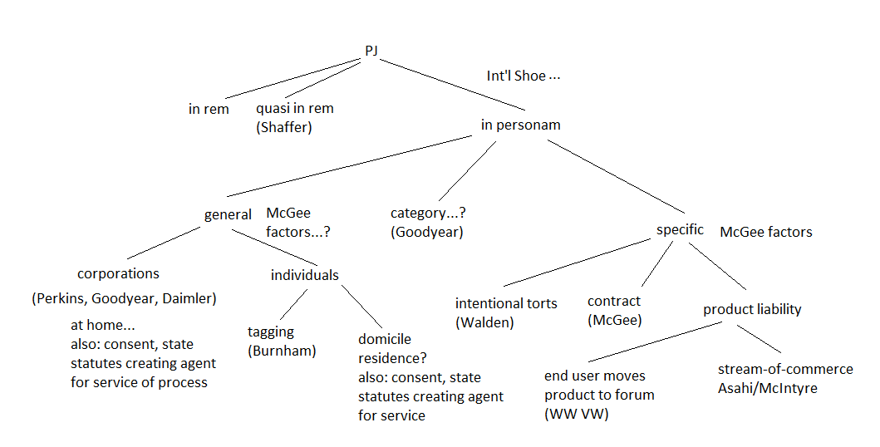
Run through some examples from \old exams

P (a citizen of Nebraska) sues D (a citizen of New York) for $100,000 damages in Nebraska state court in connection with a brawl that occurred in Illinois. D has never been to the state of Nebraska and owns no property there. D appears to argue that the Nebraska state court lacks personal jurisdiction over her. Under Nebraska state law, however, motions to dismiss for lack of personal jurisdiction are not allowed: Anyone appearing before a Nebraska state court, even when arguing lack of personal jurisdiction, submits himself to general personal jurisdiction.
D argues that the Nebraska state law is unconstitutional. Is she right?
- no special appearances allowed

how to answer
- not enough to say OK under Pennoyer
- What about Now? (think of Shaffer, which struck down a form of PJ that was OK under Pennoyer)
- what cases to look at? Burnham/Shaffer
  - These are cases that consider forms of personal jurisdiction that were OK under Pennoyer but that are difficult to justify under Shoe

- could say that this is in effect a form of tagging and tagging good under Burnham so OK now
- BUT Burnham involved case where D came willingly and for business
- here D is appearing only to argue no PJ
- Brennan theory in Burnham
  - must satisfy Int’l Shoe
    - Arguably does not, because the defendant is not willingly getting the benefits of protection of the forum state

- Scalia theory in Burnham
  - Arguably does not satisfy his theory either
  - – it is true that the denial of a special appearance was permissible at the time of the enactment of the 14th amendment
  - But it is not generally accepted today by the states
  - states allow special appearances

Q. The D Corp (incorporated in Oregon) manufactures thimbles. It engaged in a national search to locate a suitable engineer to work at its only manufacturing plant, located in Medford, Oregon. The search involved a number of advertisements in a trade publication with a national circulation and the use of a company that specializes in recruiting highly trained employees. In the end, the recruitment company located P, who lived in Yreka, California – only 50 miles from Medford, Oregon. In a letter sent from the D Corp’s main office in Medford to P’s home in Yreka, the D Corp offered P a job, which P accepted. P decided to continue living in Yreka and to commute the fifty miles to work. That P continued to live in California was known to the D Corp.
P got into a serious accident working on a machine at the Oregon factory and decided to sue the D Corp under state-law negligence concerning the design of the machine. P brought his suit in the Federal District Court for the Eastern District of California (which includes the town of Yreka). The D Corp made a motion to dismiss for lack of personal jurisdiction.
The D Corp’s other contacts with the state of California are the following: The D Corp’s thimbles are sold all over the world, including in California, although distribution of the thimbles is through an independent distributing company that takes ownership of them at the D Corp plant in Oregon. The D Corp sells about 100,000 thimbles per year in California (around 33,000 of which are sold in the Eastern District of California). The California sales of its thimbles amount to around $10,000 per year and constitute around 3% of the D Corp’s total yearly production. The D Corp does not advertise its thimbles in California, nor does it own property, maintain an office, or have an agent for service of process there. Should the D Corp’s motion succeed?

-PJ only if a state court in CA would (according to Fed R Civ P 4(k)(1)(A)
- CA long-arm statute is up to the limits of due process

- superficial resemblance to Asahi, McIntyre stream of commerce cases
- but these stream of commerce cases are specific jurisdiction cases
  - defendant’s product in the forum state gave rise to the cause of action.
- Here P’s cause of action concerns harm he suffered from a defective machine at the thimble factory in Oregon
- shipments of thimbles to CA are relevant insofar as they could give rise to general PJ – that is PJ over the D Corp for any cause of action, even those unrelated to the CA thimble contacts.
- but that is unlikely given Goodyear
  - and Daimler
  - even category jurisdiction would not work, because the cause of action does not concern thimbles of the sort that make it a California
      - It concerns a defective machine

  - specific jurisdiction?
    - How did D Corp’s reach out to California when looking for someone to fill the engineer position?
      - by advertising for position in CA (although P did not, it seems, ever read the ads) and, more importantly, by hiring a recruiting company that ultimately contacted P in CA. Another contact is the D Corp’s sending the offer letter to CA.
- some connection with the cause of action, because they are related to P and his employment at the D Corp.
    - But not a case like McGee, where the letter sent to the state was the very contract being sued upon. P is not suing concerning his employment contract – he is suing under tort concerning the machine at the thimble plant in Oregon.
    - one might say but for the hiring of the recruiting firm and the sending of the offer letter, P would not have taken the job and so would not have gotten into the accident in Oregon.
      - but this is a difficult argument

